
Keeping your pet safe is an uphill battle. That’s why it is so important to strengthen your pet’s immune system every day with NuVet Plus®.

From Puppy through Adulthood…
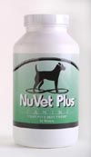
Why Strengthen
Your Pet’s
Immune System
every day?

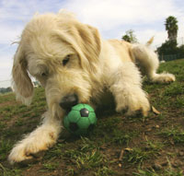

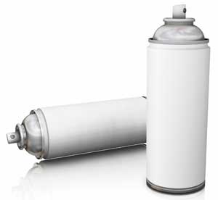

To Help Shield It From All This…

Backyard pesticides, fertilizers, bacteria, and viruses that attack your pet’s immune system;
Carpet backing, which contains formaldehyde, tuolene, benzene, xylene, styrene (Pregnant women are warned to avoid new carpets; but your pet buries his nose in it every day); also toxins are brought in on shoes (pesticides, lawn fertilizer, bacteria, viruses);
Pet Foods, most contain hormones, pesticides, meat by-products, preservatives, grain and corn (major sources of allergies)
Household Toxins (floor cleaners, bug killers,air freshener phthalates, household mold);
Pet Treats loaded with sugars and fillers, they promote diabetes and liver problems in pets;
Mouth Toxins – 80% of dogs and 70% of cats have periodontal disease by age three, dumping toxins into their bloodstream;
Seasonal Problems (allergies, dry skin).
NuVet Plus® Heals & Protects your Pet From:

* Allergies
* Skin and Coat Problems
* Scratching, Itching, Biting
* Hot Spots
* Seizures
* Arthritis - Joint Problems
* Stress / Anxiety
* Premature Aging/Low Energy
* Diabetes - Liver Problems
* Cancer (many types)
* Cataracts
* Cushing’s & Addison’s Disease
* Tumors
* Digestive Problems
* Tear Staining
* Urinary Incontinence
* Heart Disease

Safe /Natural /Water Soluble (easy on the stomach)
A tasty chewable wafer daily as a treat.

- People are surprised at how quickly and easily it works!
- GUARANTEED to eliminate your pet’s ailment - or your money back!
- Also… Helps KEEP YOUR PET HEALTHY throughout its life by strengthening its immune system!

– Not available in stores –

CALL NOW TO ORDER!
8:00 am – 5:00 pm Monday-Friday PST
800-474-7044
Order Code: 55409

or Order Online at www.nuvet.com/55409

